**WEEK 10 – PYTHON - MANIPULATING DATA PRACTICE QUESTIONS**

1. Prompt the user to enter a product description ‘BADMINTON RACKET I’ and insert a new row into the product table as follows:

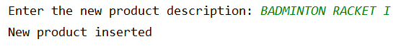

Solution

**import** sqlite3  
db = sqlite3.connect(**'u:/sqlite/teaching.db'**)  
cursor = db.cursor()  
prod_desc = input(**"Enter the new product description: "**)  
sql_insert = **"INSERT INTO product(descrip) \  
 VALUES (?)"**cursor.execute(sql_insert, (prod_desc,))  
print(**"Inserted new product"**)  
db.commit()

From SQLite, run the query SELECT * FROM product; and check that the new product has been inserted and it has a prodid value.

2. Prompt the user to enter a customer name, creditlimit and repid and insert a new row into the customer table. Check to ensure the repid entered is a valid empno of a salesman in the emp table.

Execution 1 testing the successful insert of a new customer

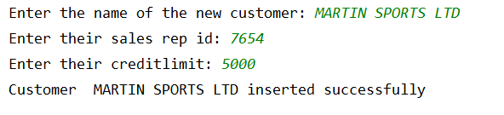

From SQLite, run the query SELECT * FROM customer; and check that the new customer has been inserted and it has a custid value.

Execution 2 testing the error is displayed if the sales rep is not a SALESMAN in the emp table

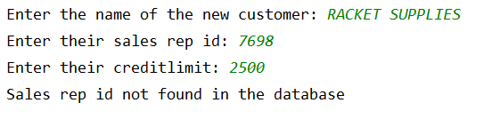

**import** sqlite3  
db = sqlite3.connect(**'c:/sqlite/teaching.db'**)  
cursor = db.cursor()  
*# enable foreign key constraints*cursor.execute(**"PRAGMA foreign_keys=ON"**)  
cust_name = input(**"Enter the name of the new customer: "**)  
cust_repid = input(**"Enter their sales rep id: "**)  
cust_creditlimit = int(input(**"Enter their creditlimit: "**))  
*# check if the sales rep id entered is a valid SALESMAN in the employee table*sql_query = **"SELECT empno \  
 FROM emp \  
 WHERE empno=? \  
 AND job='SALESMAN'"**cursor.execute(sql_query,(cust_repid,))  
emp_row = cursor.fetchone()  
**if** emp_row **is not None**:  
 *# if the sales rep id exists, insert a new row into the customer table* sql_insert = **"INSERT INTO customer (name, repid, creditlimit) \  
 VALUES (?,?,?)"** cursor.execute(sql_insert,(cust_name,cust_repid,cust_creditlimit))  
 *# commit the changes* db.commit()  
 print(**"Customer "**,cust_name, **"inserted successfully"**)  
**else**:  
 *# if the sales rep id doesnt exist, print an error message* print (**"Sales rep id not found in the database"**)

1. Prompt the user to enter a product description, standard price and minimum price. If the minimum price is greater than the standard price, print an error message otherwise insert a new row into the product and price tables with the same prodid.

Execution 1 testing the error is displayed if the minimum price is greater than the standard price

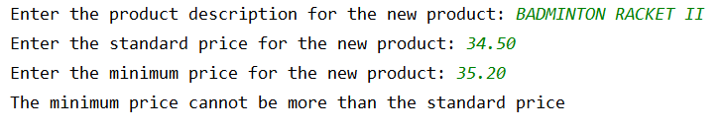

Execution 2 testing that the new rows are added successfully if the minimum price is less than or equal to the standard price

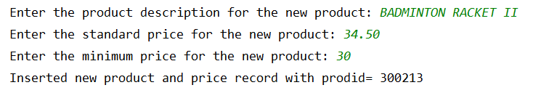

Solution

**import** sqlite3  
**import** datetime  
db = sqlite3.connect(**'c:/sqlite/teaching.db'**)  
cursor = db.cursor()  
*#get the next prodid from the sqlite_sequence table*cursor.execute(**"SELECT seq+1 \  
 FROM sqlite_sequence \  
 WHERE name='product'"**)  
next_prodid = cursor.fetchone()  
*#prompt the user to enter a product description, standard price and minimum price for the new product*prod_desc = input(**"Enter the product description for the new product: "**)  
std_price = float(input(**"Enter the standard price for the new product: "**))  
min_price = float(input(**"Enter the minimum price for the new product: "**))  
*#if the min price is invalid, print an error message***if** min_price > std_price:  
 print(**"The minimum price cannot be more than the standard price"**)  
**else**:  
 *#insert a new row into the product table for the new product* sql_insert = **"INSERT INTO product(prodid, descrip) \  
 VALUES (?, ?)"** cursor.execute(sql_insert, (next_prodid[0], prod_desc))  
 *#get todays date and convert it to the format YYYY-MM-DD* curr_date = datetime.date.today().strftime(**"%Y-%m-%d"**)  
 *#insert a new row into the price table for the new product* sql_insert = **"INSERT INTO price (prodid, startdate, stdprice, \  
 minprice, enddate) \  
 VALUES (?, ?, ?, ?, ?)"** cursor.execute(sql_insert, (next_prodid[0], curr_date, std_price, min_price, **None**))  
 print(**"Inserted new product and price record with prodid="**, next_prodid[0])  
 *#commit the changes* db.commit()

From SQLite, run the query SELECT * FROM product; and SELECT * from price; to check that the new product and price rows have been inserted with the same prodid value.

1. Prompt the user to enter a job type and a percentage between 1 and 10 and increase the monthly_sal of all the employees with that job by the percentage entered.

In SQLite, execute the query SELECT * FROM emp; to see the current monthly salaries.

Execution 1 to test when the percentage increase is outside the acceptable range

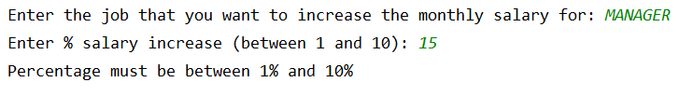

Execution 2 to test that the job can be entered in lowercase and the employees with the selected job have their monthly salary increased

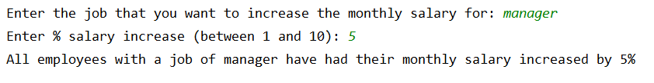

In SQLite, execute the query SELECT * FROM emp; again to see the monthly salaries of the right employees have been correctly increased.

Solution

**import** sqlite3  
**import** datetime  
db = sqlite3.connect(**'c:/sqlite/teaching.db'**)  
cursor = db.cursor()  
job_to_incr = input(**"Enter the job that you want to increase the monthly salary for: "**)  
perc_incr = int(input(**"Enter % salary increase (between 1 and 10): "**))  
*#check the percentage increase is valid***if** perc_incr >= 1 **and** perc_incr <= 10:  
 sal_multiplier = 1 + (perc_incr/100)  
 *#increase the monthly salary of all employees with the selected job* sql_update = **"UPDATE emp \  
 SET monthly_sal = monthly_sal*(?) \  
 WHERE job=UPPER(?)"** cursor.execute(sql_update,(sal_multiplier, job_to_incr))  
 *#commit any changes* db.commit()  
 print(**"All employees with a job of {0} have had their monthly salary increased by {1}%"**.format(job_to_incr, perc_incr))  
**else**:  
 print (**"Percentage must be between 1% and 10%"**)

1. Prompt the user to enter the name of an employee and delete the row for the employee with that name. If the employee you attempt to delete is a manager or salesman associated with a customer, the foreign key will prevent deletion so make sure you write an exception to handle this gracefully.

**import** sqlite3  
db = sqlite3.connect(**'c:/sqlite/teaching.db'**)  
cursor = db.cursor()  
*# enable foreign key constraints*cursor.execute(**"PRAGMA foreign_keys=ON"**)  
*# start of code where exception needs to be handled***try**:  
 *# check if employee entered exists in the database* emp_name = input(**"Enter the name of the employee to delete "**)  
 sql_query = **"SELECT empno FROM emp WHERE \  
 UPPER(ename)=UPPER(?)"** cursor.execute(sql_query,(emp_name,))  
 emp_row = cursor.fetchone()  
 empno = emp_row[0]  
 *# if employee exists then try to delete them* **if** emp_row **is not None**:  
 sql_delete = **"DELETE FROM emp WHERE empno=(?)"** cursor.execute(sql_delete,(empno,))  
 *# commit the changes* db.commit()print(**"Employee "**,emp_name, **"deleted successfully"**)  
 **else**:  
 print (**"Employee entered not found in database"**)  
**except** db.Error:  
 print (**"Employee cannot be deleted as they are a manager or sales rep"**)

Test the code three times by entering an invalid employee, entering an employee who is a manager or sales rep and finally by entering a valid employee who is a CLERK.

From SQLite, run the query SELECT * FROM emp and check that the employee has been successfully deleted.